ChurnAI: - Python & FastAPI & Scikit-Learn - Logistic Regression

Project Description:
ChurnAI is an end-to-end machine learning web application that predicts the probability of a telecom customer discontinuing their subscription, classifies the customer into a risk band, and generates real-time, actionable retention recommendations for business teams. The platform combines a trained classification model with engineered domain features, a tuned decision threshold, a persistent SQLite audit log of every prediction made, and an interactive multi-page web dashboard that visualizes churn drivers and historical activity.
The project spans the complete ML lifecycle: exploratory data analysis and cleaning of the IBM Telco Customer Churn dataset, domain-driven feature engineering, comparison of multiple classification algorithms, threshold optimization for the best precision/recall trade-off, and serialization of the final model artifacts. These artifacts are then served through a FastAPI backend that exposes prediction, history, and analytics endpoints, consumed by a vanilla JavaScript + Chart.js/Plotly.js frontend styled as a glassmorphism-inspired executive dashboard.

Scenarios
Scenario 1: A retention manager enters the profile of a fibre-optic customer on a month-to-month contract with a high monthly charge and only three months of tenure. ChurnAI instantly returns a High Risk classification with a churn probability above 70%, along with recommendations to offer a loyalty discount and transition the customer to a fixed-term contract.
Scenario 2: An operations analyst opens the Analytics page to review churn drivers across the customer base — comparing churn rates by contract type, internet service, and monthly charges — and inspects the logistic regression coefficients to understand which features most increase churn risk.
Scenario 3: A support lead reviews the Prediction History page to audit every churn assessment made that week, searching by customer ID or risk level, and clears stale test records directly from the dashboard before the next reporting cycle.

Technical Architecture:
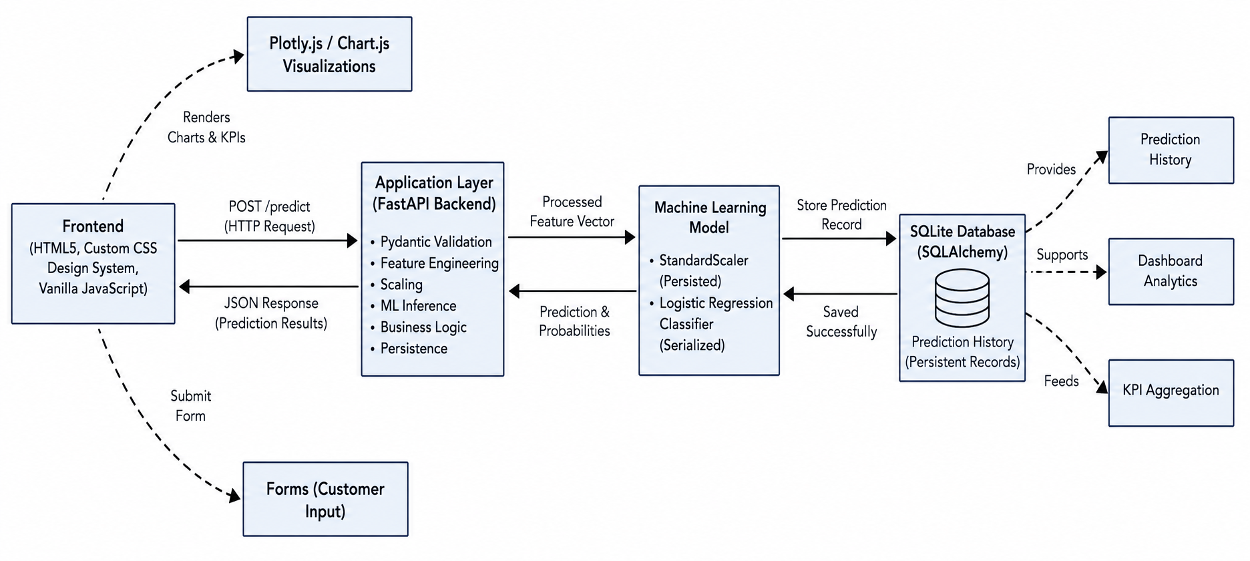

Description: ChurnAI follows a three-tier architecture. The presentation layer is a static multi-page frontend (HTML5, custom CSS design system, vanilla JavaScript) that renders KPI cards, forms, and Chart.js / Plotly.js visualizations. The application layer is a FastAPI backend that validates requests with Pydantic, re-applies the training-time feature engineering pipeline, scales inputs with a persisted StandardScaler, and runs inference through a serialized Logistic Regression classifier. The data layer is a SQLite database accessed through SQLAlchemy, which persists every prediction as an auditable historical record.

Flow: Frontend form submission → POST /predict → Pydantic validation (CustomerInput) → feature engineering (calculate_engineered_features) → feature vector construction → StandardScaler transform → Logistic Regression inference → threshold-based classification → business recommendation generation → SQLite persistence → JSON response rendered back into the dashboard.

ER DIagram :

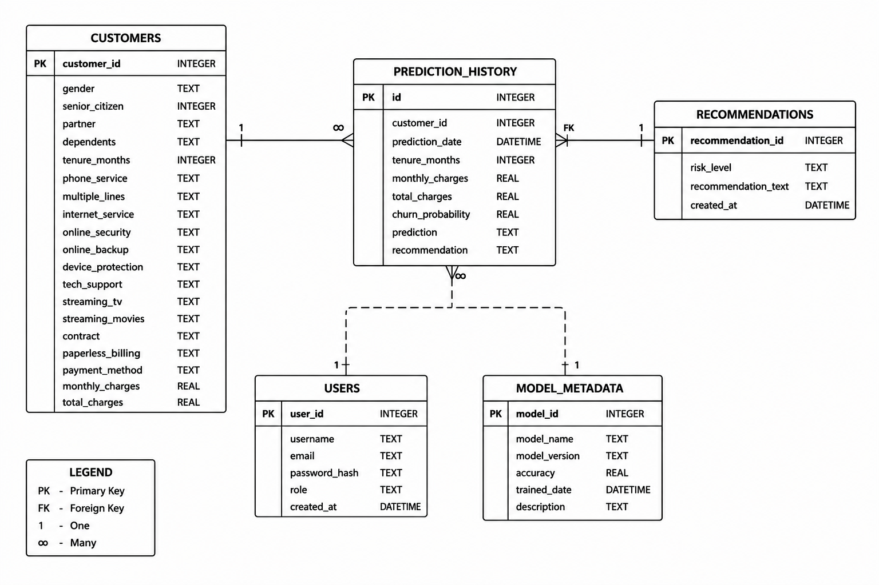
Description : This is a 5-table churn prediction database: each customer has many prediction history records tracking their churn probability and outcome over time, and each prediction links to a recommendation, the user who ran it, and the model version used to generate it.

Pre-requisites:
- Python Programming Proficiency:https://docs.python.org/3/
- Machine Learning & Pandas/Scikit-learn: https://pandas.pydata.org/docs/
https://scikit-learn.org/stable/documentation.html
- FastAPI Framework Knowledge: https://fastapi.tiangolo.com/
- SQLAlchemy ORM: https://docs.sqlalchemy.org/
- HTML, CSS, and JavaScript Skills: https://www.w3schools.com/
- Chart.js / Plotly.js Familiarity: https://www.chartjs.org/docs/latest/
https://plotly.com/javascript/
- Version Control with Git: https://git-scm.com/doc
- Development Environment Setup: https://docs.python.org/3/library/venv.html
- Package Management: https://pip.pypa.io/en/stable/

Project Workflow:

Milestone 1: Data Analysis, Feature Engineering & Model Selection
- Activity 1.1: Load, clean, and understand the IBM Telco Customer Churn dataset.
- Activity 1.2: Perform exploratory data analysis to uncover churn drivers.
- Activity 1.3: Engineer domain-specific features to boost model sensitivity.
- Activity 1.4: Train and compare Logistic Regression, Random Forest, and XGBoost classifiers.
- Activity 1.5: Tune the classification threshold and serialize the final model artifacts.

Milestone 2: Backend Schema & Prediction Pipeline Development
- Activity 2.1: Design Pydantic input/output validation schemas.
- Activity 2.2: Build the feature engineering and inference pipeline.

Milestone 3: FastAPI Backend & Database Development

Activity 3.1: Develop REST API routes for prediction, history, and analytics.

Activity 3.2: Integrate SQLite for persistent prediction audit logging.

Milestone 4: Frontend Development
- Activity 4.1: Build the multi-page glassmorphism dashboard UI.
- Activity 4.2: Implement dynamic data rendering and Chart.js/Plotly.js visualizations.

Milestone 5: CLI Tooling & Automated Testing

Activity 5.1: Build a standalone CLI script for custom predictions.

Activity 5.2: Write unit and integration tests for the pipeline and API.

Milestone 6: Deployment

Activity 6.1: Prepare and run the application locally via Uvicorn.
Conclusion

Milestone 1: Data Analysis, Feature Engineering & Model Selection
This milestone covers the full data-science workflow captured in Customer churn prediction.ipynb from raw data cleaning through to a serialized, production-ready classifier.

Activity 1.1: Dataset Understanding & Data Cleaning

Loaded the IBM Telco Customer Churn dataset (WA_Fn-UseC_-Telco-Customer-Churn.csv), containing 7,043 customer records across demographic, account, and service columns.

Converted the TotalCharges column to numeric using pd.to_numeric(errors="coerce"), since blank strings were preventing correct typing.

Dropped rows with missing values after coercion and confirmed there were no duplicate records.

Removed the non-predictive customerID identifier column.

Checked class balance on the Churn target — confirming a moderately imbalanced dataset, which informed the choice of evaluation metrics (Precision, Recall, F1-Score, ROC-AUC over raw accuracy).

Activity 1.2: Exploratory Data Analysis (EDA)

Visualized the overall churn distribution to confirm class imbalance.

Compared churn rates across Contract type, finding month-to-month customers churn far more than one- or two-year contract holders.

Analyzed tenure and MonthlyCharges distributions against churn using box plots — shorter tenure and higher monthly charges both correlate with higher churn.

Compared InternetService and PaymentMethod against churn using grouped bar charts, finding fibre-optic customers and electronic-check payers churn more.

Generated a correlation heatmap across numeric features to identify multicollinearity and churn-correlated variables.
Key business insights: Month-to-month contracts have the highest churn; shorter tenure and higher monthly charges increase churn risk; internet service type and payment method both show a measurable relationship with churn behavior.

Activity 1.3: Feature Engineering
Six domain features were engineered to increase the model's predictive signal beyond the raw survey columns:
- Customer Lifetime Value (CLV): MonthlyCharges × tenure — approximates cumulative revenue generated by the customer.
- Average Monthly Spend: TotalCharges ÷ (tenure + 1) — smooths spending velocity over the customer's lifecycle.
- Total Services: count of subscribed add-ons (Phone, Multiple Lines, Online Security, Online Backup, Device Protection, Tech Support, Streaming TV, Streaming Movies) equal to "Yes".
- Long-Term Customer: binary flag set to 1 when tenure ≥ 24 months.
- Monthly Contract: binary flag set to 1 when Contract == "Month-to-month".
- Internet Service Count: sum of internet add-on subscriptions (Security, Backup, Support, Streaming TV/Movies).
Categorical columns were one-hot encoded with pd.get_dummies(drop_first=True), and the engineered dataset was exported to customer_churn_feature_engineered.csv for downstream analytics use.

Activity 1.4: Model Training & Comparison

Split the data 80/20 into train and test sets using train_test_split(stratify=y, random_state=42) to preserve class balance.

Scaled numeric features with StandardScaler prior to training the linear model.

Trained and evaluated three classifiers on Accuracy, Precision, Recall, F1-Score, and ROC-AUC: Logistic Regression, Random Forest (200 estimators), and XGBoost (200 estimators, learning_rate=0.05, max_depth=5).
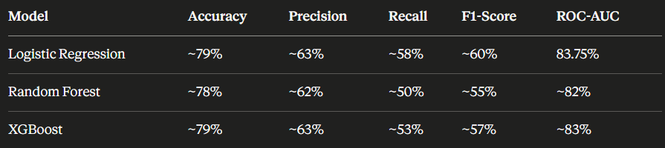

Table 1: Model comparison from the notebook's evaluation cell — Logistic Regression was selected for its strong ROC-AUC, interpretability of coefficients, and stable calibration for threshold tuning.

Activity 1.5: Threshold Tuning, Evaluation & Serialization
- Rather than the default 0.5 cutoff, tuned a custom decision threshold of 0.38 on the predicted probabilities to better balance precision and recall for churn identification.
- Generated a classification report and confusion matrix on the held-out test set to validate performance at the chosen threshold.
- Extracted and ranked the Logistic Regression coefficients by absolute value to produce a feature-importance table used later by the Analytics dashboard.
- Serialized the final artifacts with joblib for reuse by the backend: churn_model.pkl, scaler.pkl, threshold.pkl, and feature_names.pkl (the exact 35-column feature order expected by the model).

import joblib

joblib.dump(log_model, "churn_model.pkl")
joblib.dump(scaler, "scaler.pkl")
joblib.dump(threshold, "threshold.pkl")
joblib.dump(list(X_train.columns), "feature_names.pkl")

Milestone 2: Backend Schema & Prediction Pipeline Development
Milestone 2 focuses on backend/models.py and backend/predict.py — translating the notebook's feature engineering logic into a reusable, validated Python pipeline that the API can call on every request.

Activity 2.1: Pydantic Input/Output Schema Design (models.py)
- Defined a CustomerInput schema covering all 17 raw customer attributes (demographics, services, contract, billing) required for a prediction.
- Added field_validator methods to strictly enforce categorical value sets — e.g. Gender must be "Male" or "Female"; InternetService must be "DSL", "Fiber optic", or "No"; Contract must be one of the three valid plan types — returning descriptive validation errors on bad input.
- Defined PredictionResponse (customer_id, probability, prediction, risk_level, engineered_features, business_recommendations, timestamp) and PredictionHistoryRecord output schemas so FastAPI can auto-generate response documentation.
class CustomerInput(BaseModel):
gender: str
SeniorCitizen: int
tenure: int = Field(..., ge=0)
Contract: str
MonthlyCharges: float = Field(..., ge=0)
...

@field_validator('Contract')
def validate_contract(cls, v):
if v not in ['Month-to-month', 'One year', 'Two year']:
raise ValueError("Invalid Contract value")
return v

Activity 2.2: Feature Engineering & Inference Pipeline (predict.py)
- Implemented load_prediction_assets() to lazily load and cache the model, scaler, threshold, and feature-name list from backend/models/*.pkl on first use.
- Implemented calculate_engineered_features(), replicating the notebook's six engineered features (CLV, Average Monthly Spend, Total Services, Long-Term Customer flag, Monthly Contract flag, Internet Service Count) at inference time.
- Implemented construct_feature_vector() to map the raw and engineered fields onto the exact 35-column one-hot-encoded order stored in feature_names.pkl, guaranteeing consistency between training and serving.
- Implemented predict_churn() as the single orchestration function: scales the vector, calls model.predict_proba(), applies the tuned 0.38 threshold, assigns a risk band (Low < 40%, Medium 40–70%, High ≥ 70%), and generates a list of business recommendations tailored to risk level, contract type, and tech-support status.
def predict_churn(customer: CustomerInput):
model, scaler, threshold, feature_names = load_prediction_assets()
engineered = calculate_engineered_features(customer)
vector = construct_feature_vector(customer, engineered, feature_names)
scaled = scaler.transform([vector])
probability = float(model.predict_proba(scaled)[0, 1])
is_churn = probability >= threshold
...
return probability, prediction_label, risk_level, engineered, recommendations

Milestone 3: FastAPI Backend & Database Development
Milestone 3 covers backend/main.py and backend/database.py — the REST layer that exposes the prediction pipeline to the frontend and persists every request for later audit.

Activity 3.1: REST API Route Development (main.py)
- Configured the FastAPI app with CORS middleware to allow the frontend to call the API during development.
- Implemented GET /health for a lightweight server status and timestamp check.
- Implemented POST /predict: validates the CustomerInput payload, runs predict_churn(), generates a sequential customer ID (CHURN-100x), persists the result to SQLite, and returns the full PredictionResponse.
- Implemented GET /history to return every stored prediction ordered by most recent, and DELETE /history to clear the audit log.
- Implemented GET /api/analytics to aggregate churn distribution, contract-vs-churn, monthly-charges and tenure distributions, internet-service-vs-churn counts, top-15 feature-importance coefficients, and a sampled predicted-probability distribution — falling back to representative mock aggregates when the raw dataset CSV isn't present.
- Mounted the static frontend directory with StaticFiles(html=True) so the API and the UI are served from the same origin.
@app.post("/predict", response_model=PredictionResponse)
def run_predict(customer: CustomerInput, db: Session = Depends(get_db)):
prob, pred_label, risk, eng_features, recommendations = predict_churn(customer)
customer_id = f"CHURN-{1000 + db.query(PredictionDBModel).count() + 1}"
db_record = PredictionDBModel(customer_id=customer_id, probability=round(prob*100,2),
prediction=pred_label, risk_level=risk, ...)
db.add(db_record); db.commit()
return PredictionResponse(customer_id=customer_id, probability=round(prob*100,2), ...)

Activity 3.2: SQLite Audit Logging (database.py)
- Configured a SQLAlchemy engine pointing at a local SQLite file (database/predictions.db) with check_same_thread=False to support FastAPI's multi-threaded request handling.
- Defined the PredictionDBModel ORM table storing customer_id, probability, prediction, risk_level, timestamp, and the full JSON-serialized input payload for traceability.
- Implemented init_db() to create tables on startup and a get_db() generator dependency for safe session lifecycle management across requests.

Milestone 4: Frontend Development
Milestone 4 focuses on the frontend/ directory — a five-page static dashboard (index.html, predict.html, analytics.html, history.html, about.html) sharing a consistent sidebar-navigation shell, custom CSS design system, and vanilla JavaScript data layer.

Activity 4.1: Multi-Page Dashboard UI (HTML/CSS)
- Built a shared sidebar component (logo, nav links with active-state highlighting, version tag) reused identically across all five pages for consistent navigation.
- Designed index.html as the Executive Dashboard with KPI cards (Total Customers, Customers Churned, Retention Rate, Model F1-Score) and a Recent Activity panel pulling the latest predictions.
- Designed predict.html as an interactive single-customer churn calculator form covering every CustomerInput field.
- Designed analytics.html as a Plotly.js-powered grid of seven charts: churn distribution, contract-vs-churn, monthly-charges-vs-churn, tenure-vs-churn, internet-service-vs-churn, probability distribution, and feature-importance coefficients.
- Designed history.html with a searchable, sortable audit table (Customer ID, Probability, Risk Level, Prediction, Tenure & Contract, Monthly Charge, Timestamp) and a Clear History action.
- Designed about.html to document the tech stack, architecture, and the six engineered features for stakeholders reviewing the methodology.
- Implemented the visual language in a single custom stylesheet (style.css) — a dark glass-card design system with gradient badges, KPI color variants, and responsive table layouts.

Activity 4.2: Dynamic Rendering & Data Visualization
- Implemented app.js to route page-specific initialization logic (dashboard KPIs, predict form, history table, analytics trigger) based on the current pathname on DOMContentLoaded.
- Wired the predict form to POST /predict via the Fetch API and render the returned probability, risk level, engineered features, and recommendations back into the page without a reload.
- Implemented charts.js with a shared dark Plotly theme (themeLayout) and one drawing function per chart type — donut, grouped bar, box, violin, histogram, and horizontal bar — all fed by a single GET /api/analytics call.
- Added a threshold marker line (dash-dot, red) at 0.38 on the probability-distribution histogram so viewers can see exactly where the model's decision boundary sits relative to the predicted-probability spread.

Milestone 5: CLI Tooling & Automated Testing

Activity 5.1: Standalone CLI Prediction Script (predict_custom.py)

Built a command-line script that constructs a CustomerInput object directly in Python (bypassing the API) and calls predict_churn() for quick, scriptable diagnostics.

Formatted the CLI output as a readable diagnostics report: churn probability, prediction outcome, risk level, all engineered feature values, and the generated business recommendations.
prob, label, risk, engineered, recommendations = predict_churn(custom_customer)

print(f"Churn Probability : {prob * 100:.2f}%")
print(f"Prediction Outcome: {label}")
print(f"Risk Level : {risk}")

Activity 5.2: Unit & Integration Testing (test_predict.py)
- Wrote unittest-based tests covering asset loading (model, scaler, threshold, 35 feature names), engineered-feature calculations against a known sample, and correct feature-vector-to-column-index mapping.
- Wrote FastAPI TestClient integration tests covering the health check, the full history CRUD flow (clear → verify empty → predict → verify count), the analytics aggregation endpoint's response shape, and the customer-lookup-by-index endpoint including an out-of-bounds error case.
- Ran the suite with pytest backend/test_predict.py to validate the pipeline end-to-end before every deployment.

Milestone 6: Deployment

Milestone 6 covers preparing and running ChurnAI locally so the dashboard, prediction API, and Swagger documentation are all reachable from a browser.

Activity 6.1: Local Environment Setup & Server Launch

Cloned the repository and created an isolated virtual environment for the project dependencies.
git clone https://github.com/your-username/Customer-Churn-Prediction.git
cd Customer-Churn-Prediction
python -m venv .venv
source .venv/bin/activate # Windows: .\.venv\Scripts\Activate.ps1
pip install -r backend/requirements.txt

- Launched the FastAPI server with Uvicorn in reload mode for local development.

python -m uvicorn backend.main:app --host 127.0.0.1 --port 8000 --reload

- Verified the deployment by opening the dashboard at http://127.0.0.1:8000 and the interactive Swagger docs at http://127.0.0.1:8000/docs.
- On startup, init_db() creates the SQLite schema automatically and load_prediction_assets() pre-loads the model artifacts into memory so the first prediction request isn't slowed by disk I/O.

Exploring the Website’s Web Pages:

Executive Dashboard :

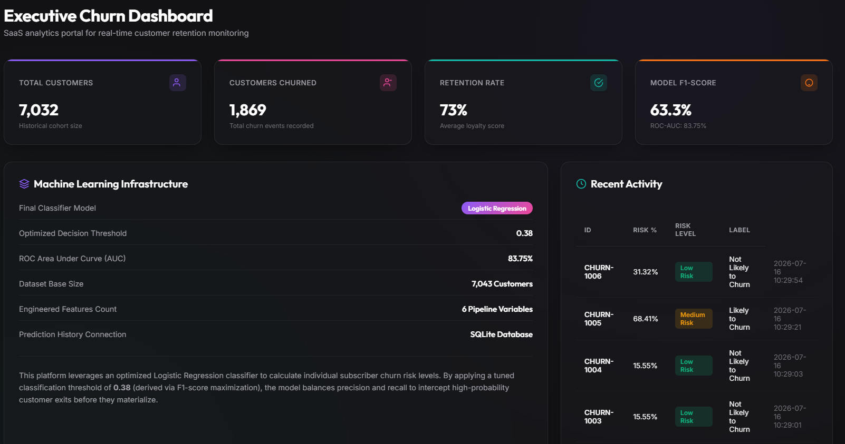

Description: The landing page of ChurnAI, presenting four KPI cards — Total Customers, Customers Churned, Retention Rate, and Model F1-Score — alongside a Machine Learning Infrastructure panel detailing the classifier, decision threshold (0.38), ROC-AUC (83.75%), and dataset size. A Recent Activity table on the right shows the latest predictions pulled live from the history endpoint.

Predict Customer :
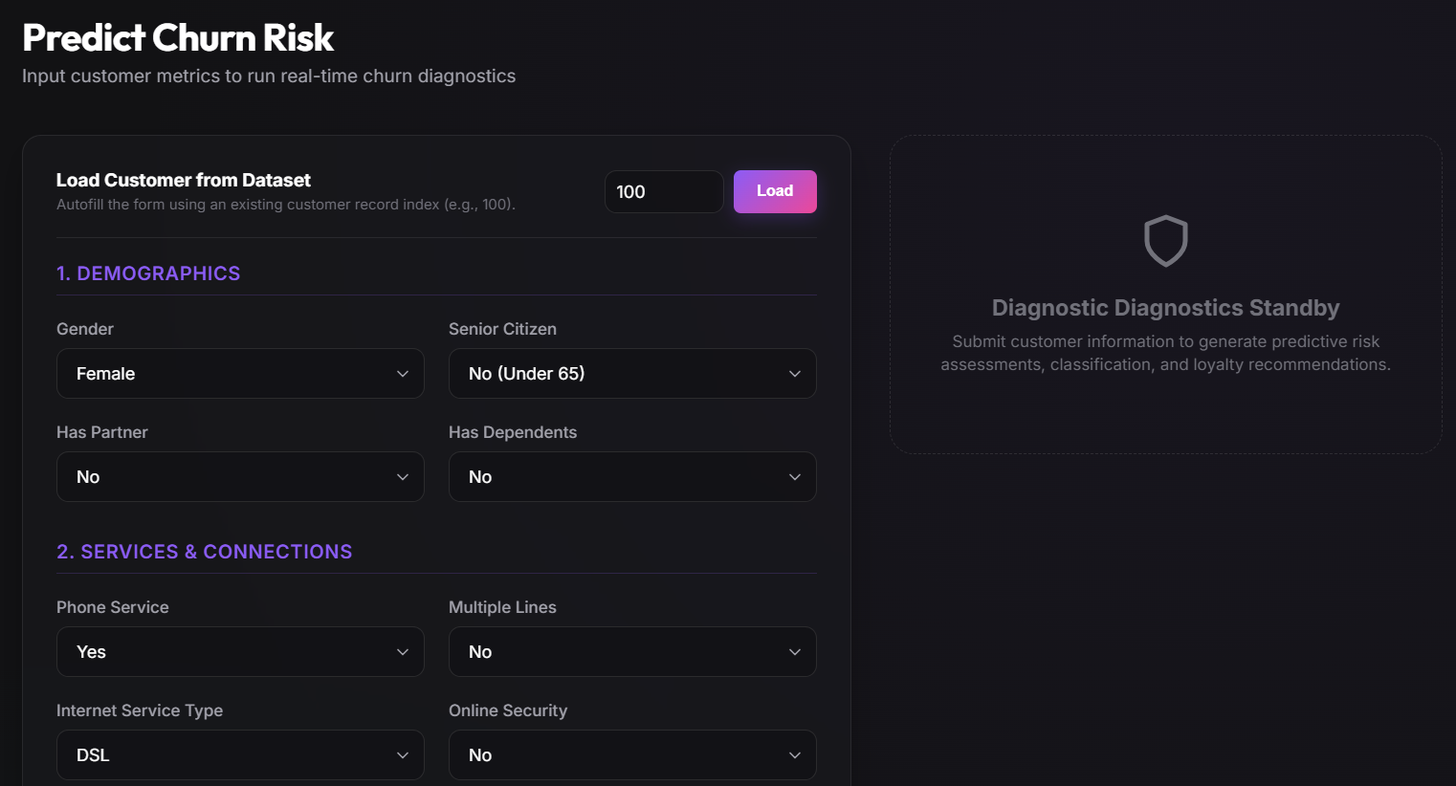
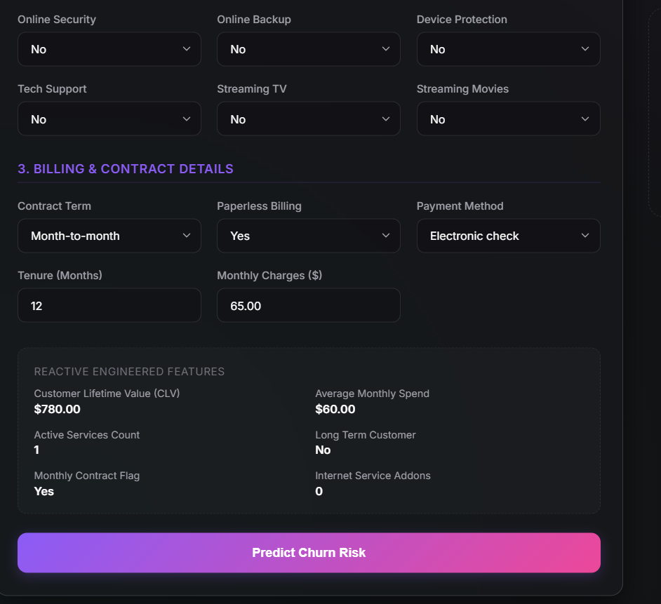
Description: An interactive single-customer churn calculator. Users fill in demographic, service, contract, and billing fields; on submission the form calls POST /predict and renders the churn probability, risk level, engineered features, and tailored retention recommendations directly on the page.

Analytics :
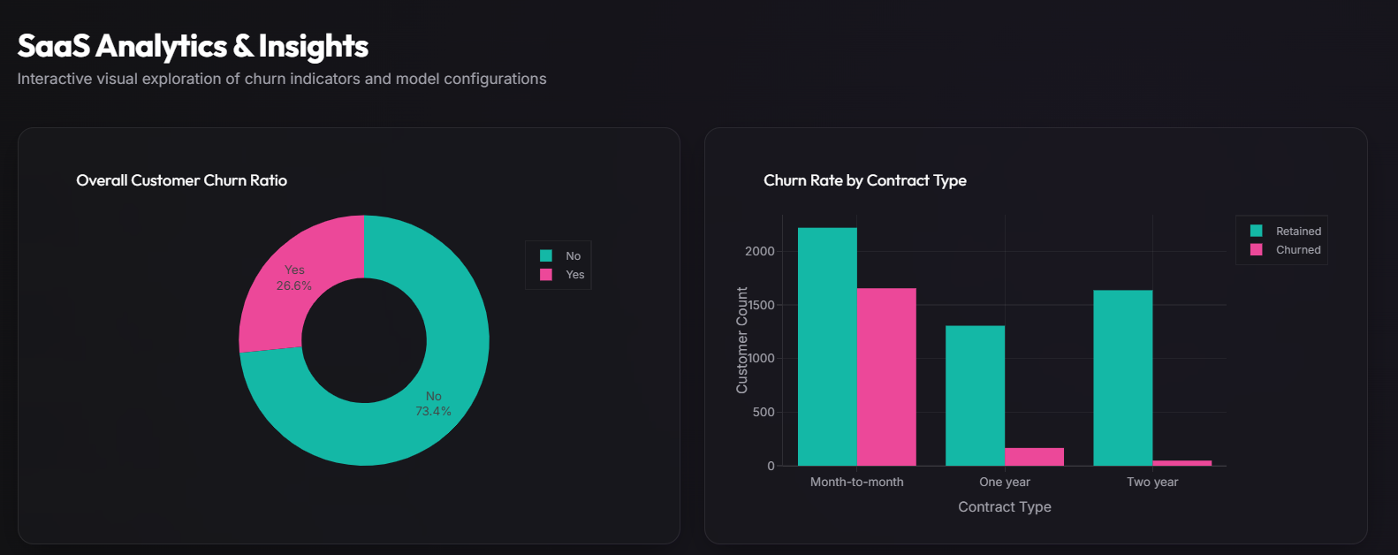

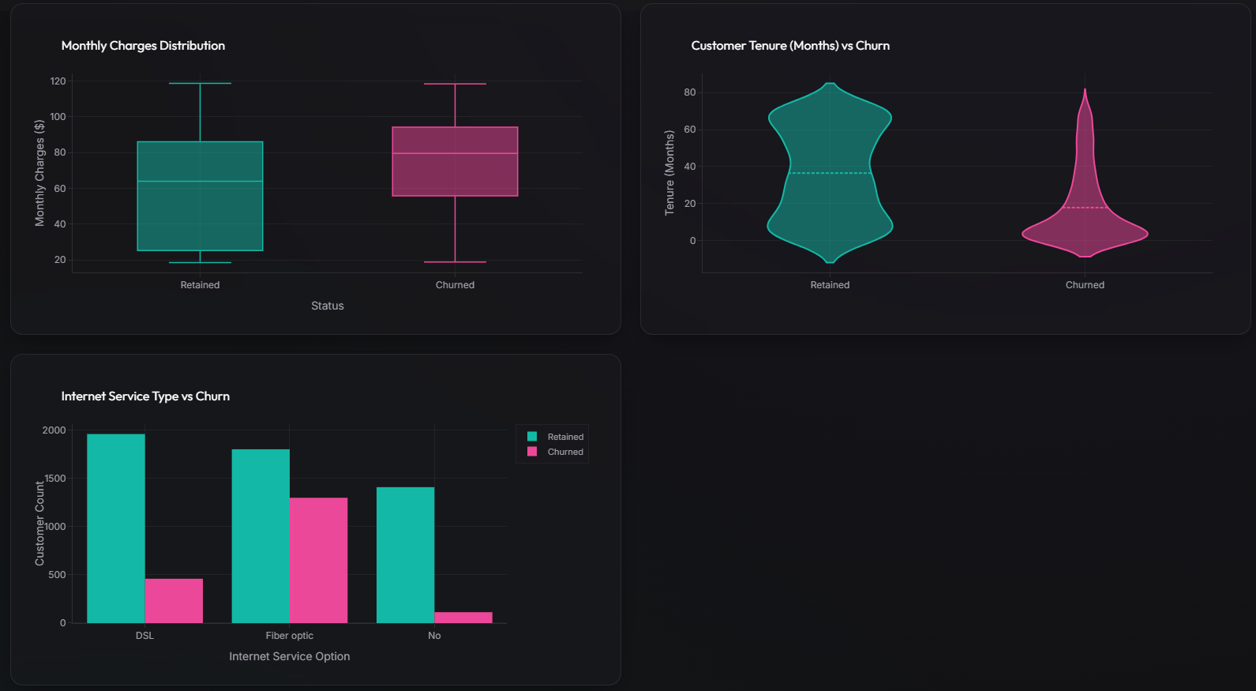
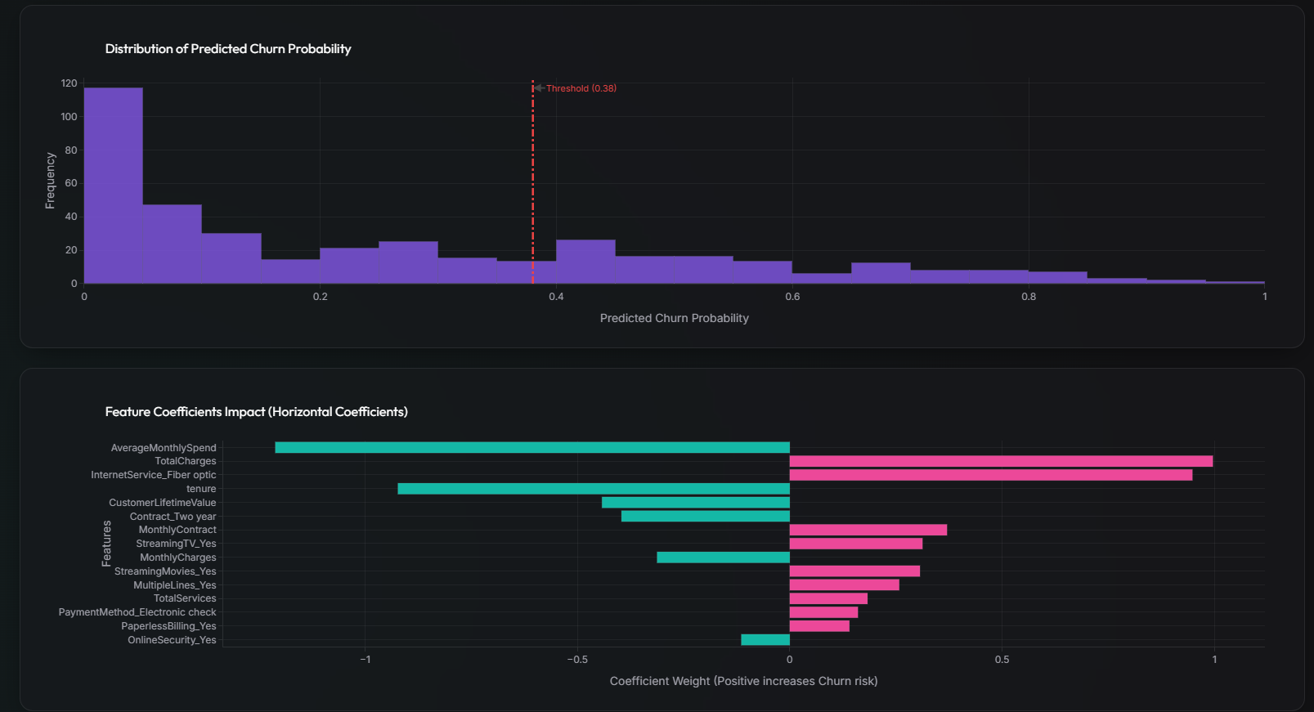
Description: A seven-chart Plotly.js dashboard for deep-dive exploration: churn ratio, contract-type churn comparison, monthly-charge and tenure distributions by churn status, internet-service churn comparison, the model's predicted-probability distribution with the 0.38 threshold marked, and the top feature coefficients driving churn risk up or down.

Prediction :
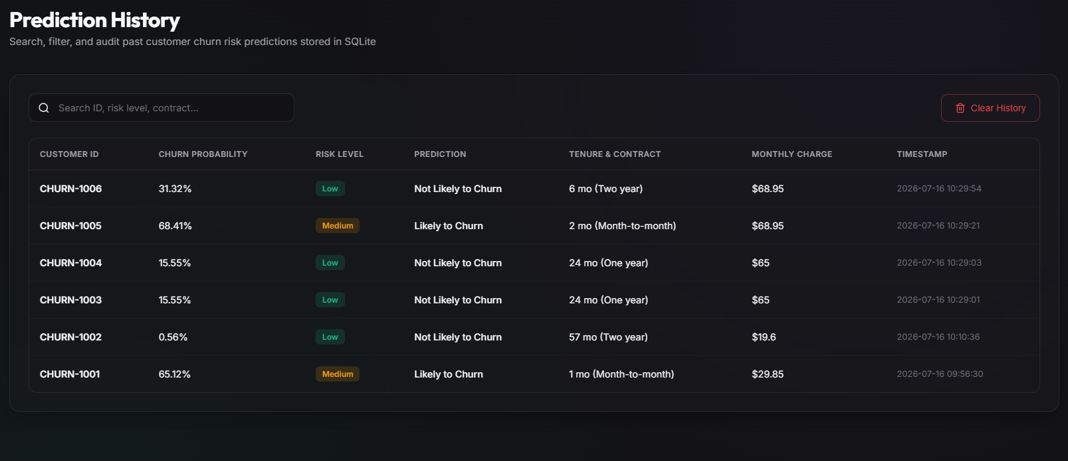

Description : A searchable, filterable audit table of every prediction made through the platform, showing customer ID, churn probability, risk level, prediction outcome, tenure/contract, monthly charge, and timestamp — with a one-click Clear History action backed by DELETE /history.

About Project :
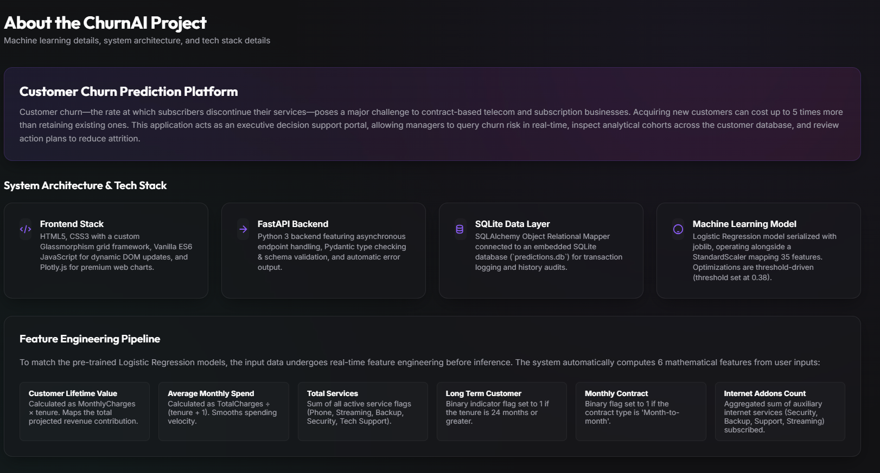

Description : A methodology and architecture reference page documenting the frontend/backend/data-layer tech stack and the six engineered features used by the model, intended for stakeholders reviewing how the system works.
API End point References :

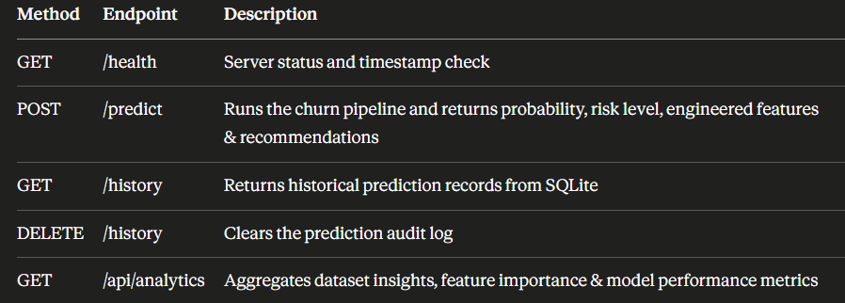

Conclusion:
ChurnAI is a complete, production-style churn prediction system that carries a Logistic Regression classifier from exploratory notebook analysis all the way to a served, auditable web application. Domain-driven feature engineering, threshold-tuned classification, and a FastAPI + SQLAlchemy backend combine with a Chart.js/Plotly.js dashboard to give retention teams instant, explainable churn risk assessments and a persistent record of every decision made. The project demonstrates the full ML engineering lifecycle — data cleaning, EDA, feature engineering, model comparison, threshold optimization, API design, database integration, frontend visualization, CLI tooling, and automated testing — in a single cohesive codebase.
Looking ahead, ChurnAI has clear paths for expansion: retraining on live production data to fight model drift, adding authentication and role-based access for enterprise use, introducing model explainability (e.g. SHAP values) directly in the UI, and deploying behind a managed cloud host with CI/CD for continuous delivery. These enhancements would move ChurnAI from a strong portfolio project toward an enterprise-ready retention platform.

